The Collegiate School Parent Registration 2024-2025
Website address: https://pccc.focusschoolsoftware.com/focus/auth/

Click on the first option:
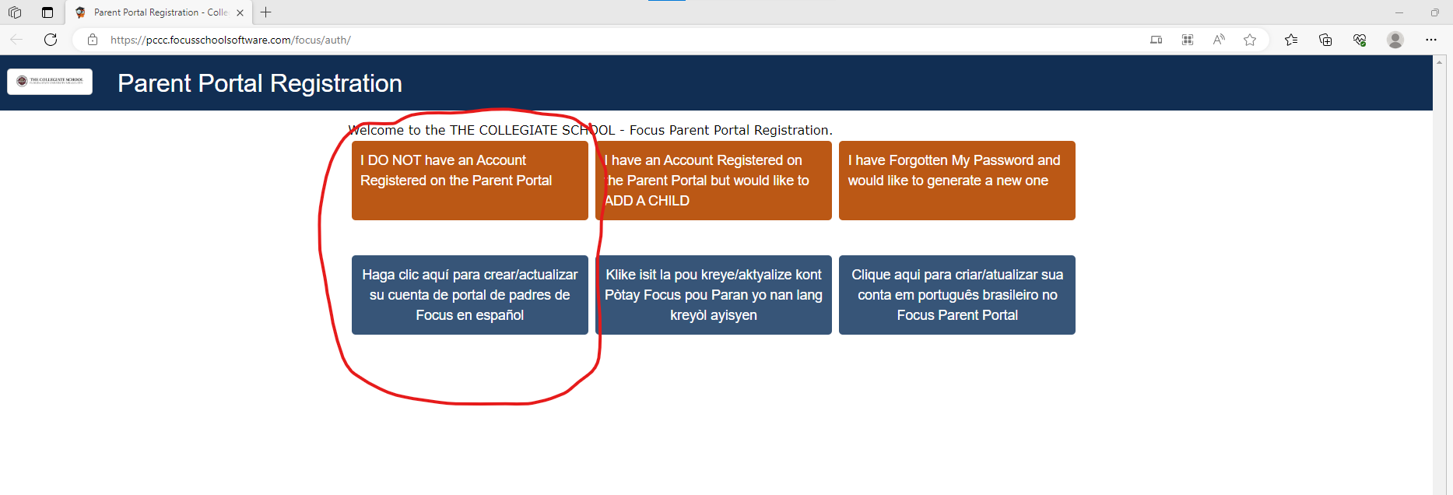

Create an account and click submit: 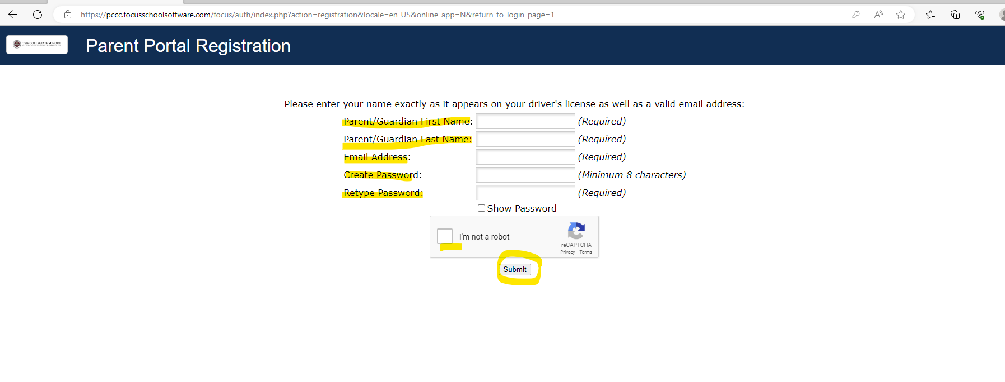Select the middle option: 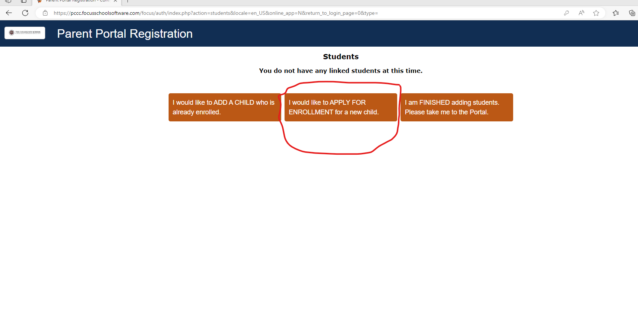
Complete required information then Select “The Collegiate School Parent Registration” and click Begin Application.
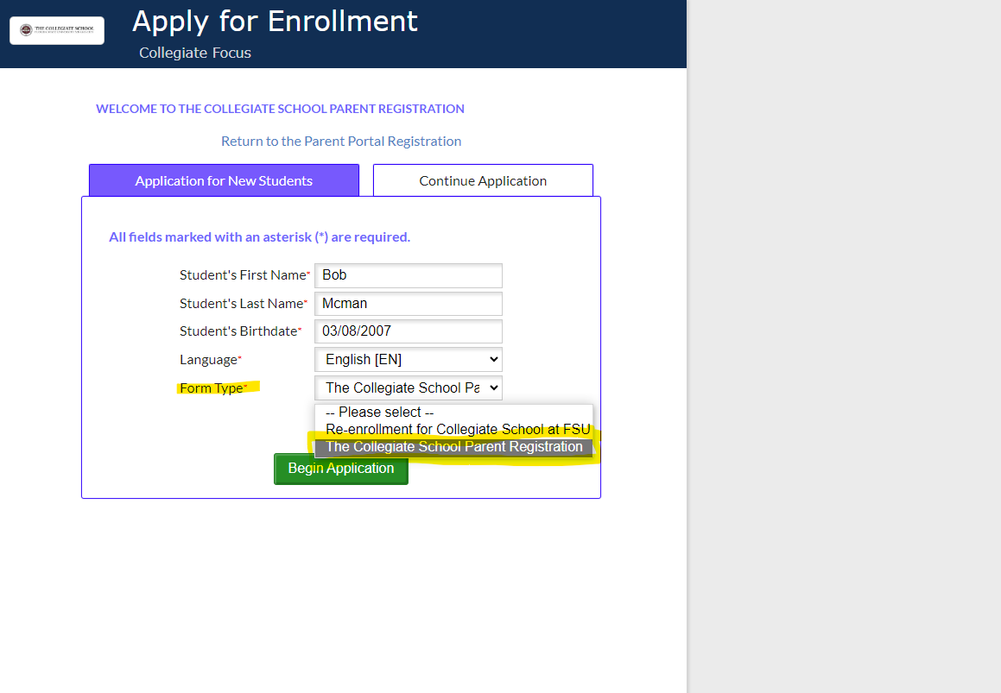
Click the Next Page button to continue:
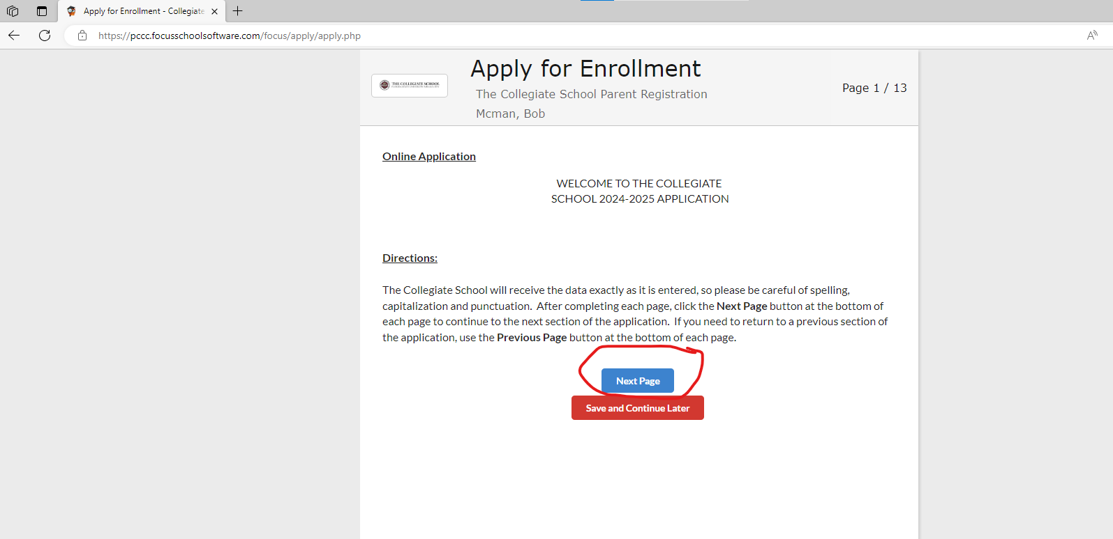

Fill in needed fields and in the Application School Year drop down box select Next School Year: 2024-2025 and click Next Page: 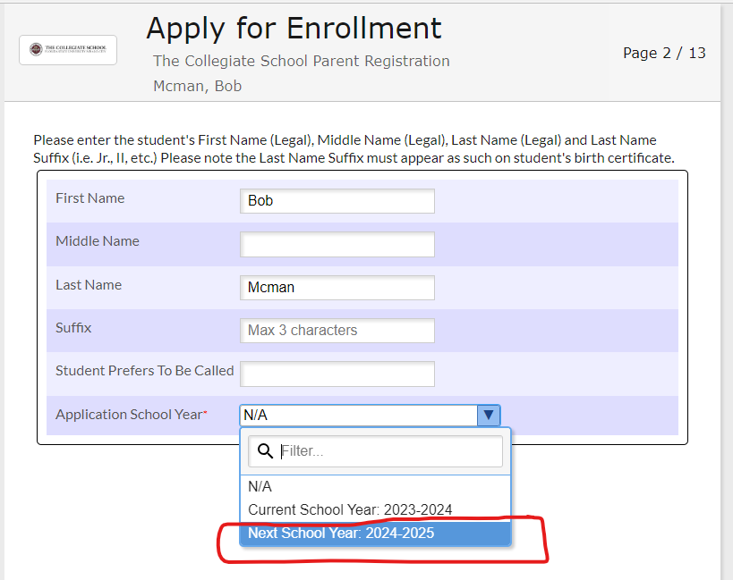
Complete the needed information and click Next Page:
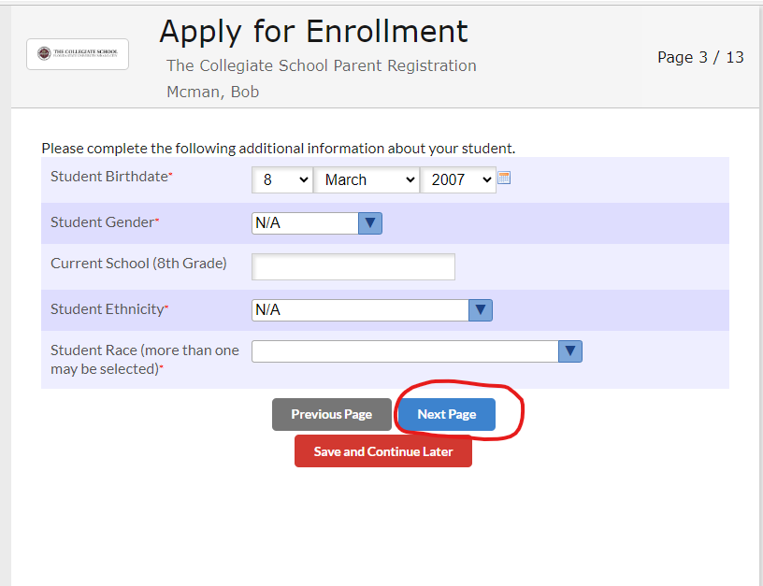

Use the drop-down boxes to answer the questions then click Next Page:
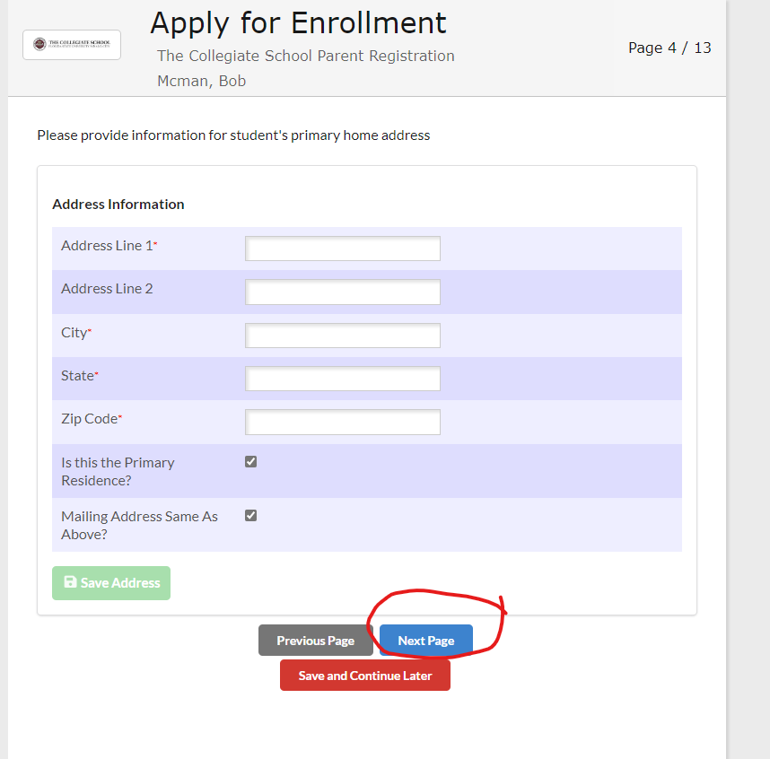

Complete Enrolling parent contact information and click Next Page:
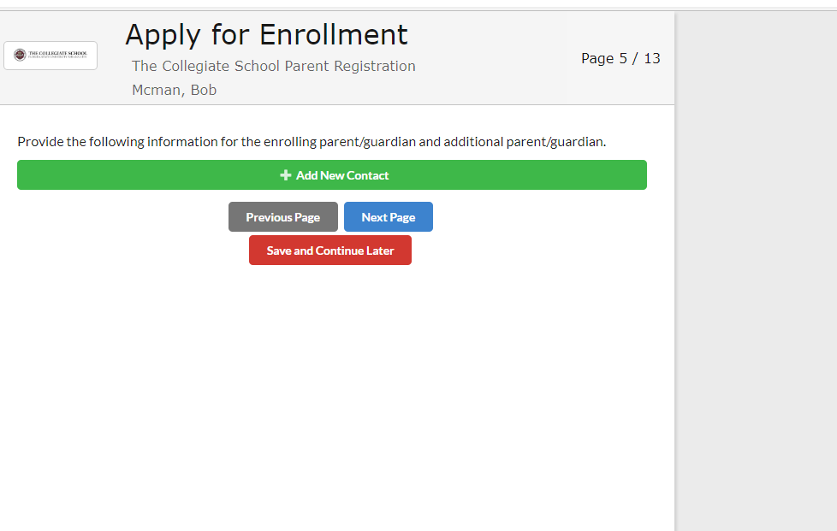

Complete Military Status information and click Next Page:

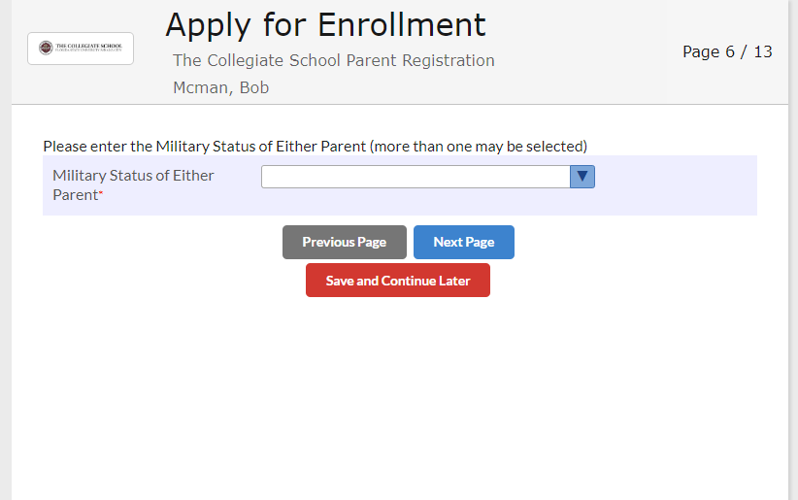

Complete the needed information and click Next Page:

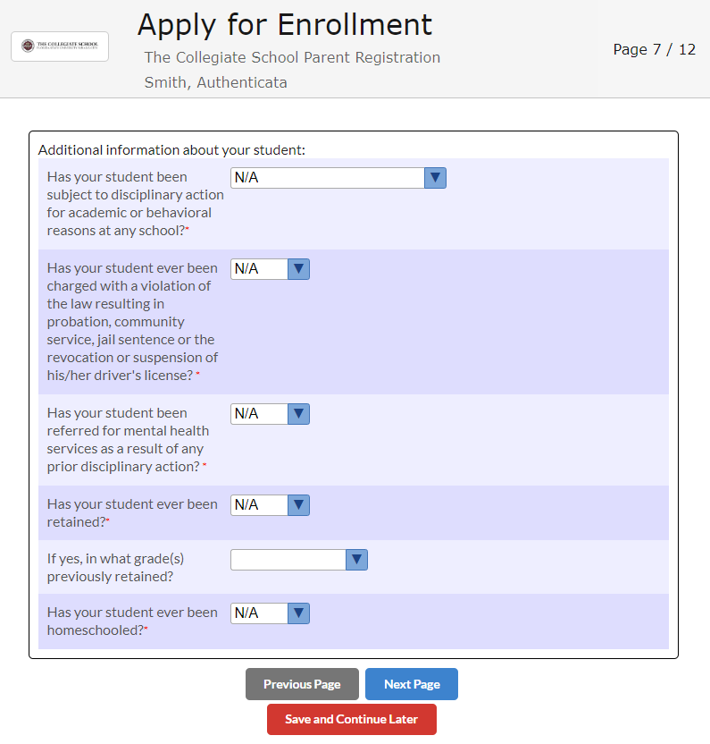

Use the drop-down boxes to answer the questions then click Next Page:
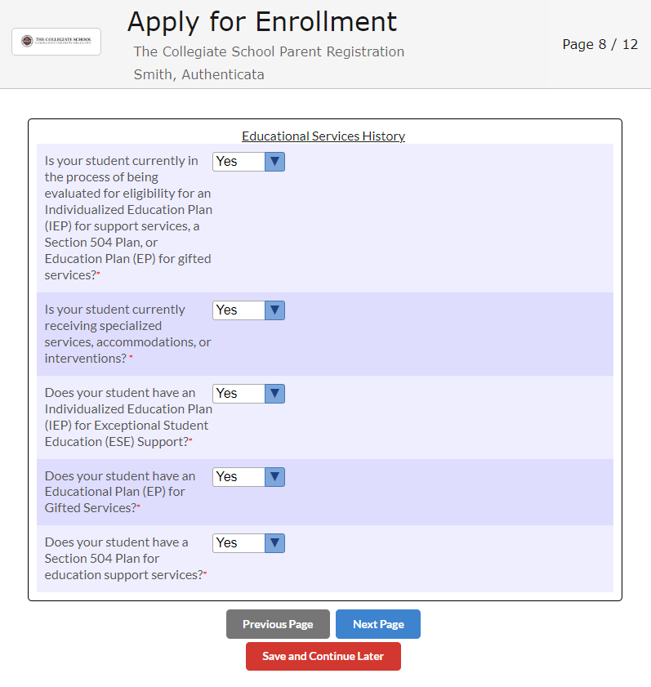

Complete the questions and click “Next Page”:

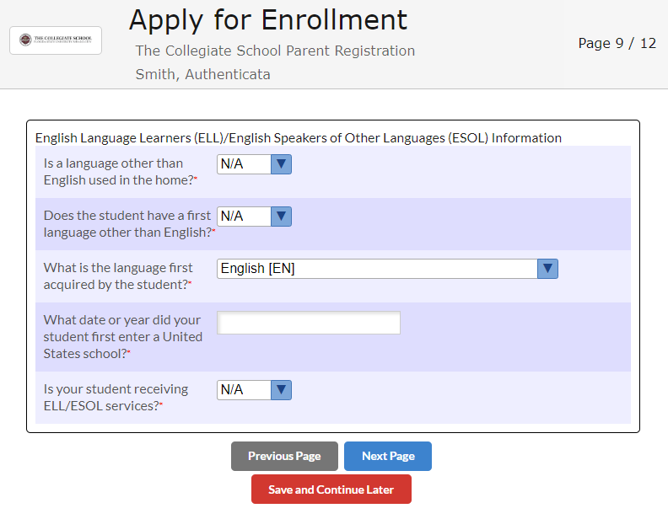

Use the drop-down boxes to answer the questions then click “Next Page”:
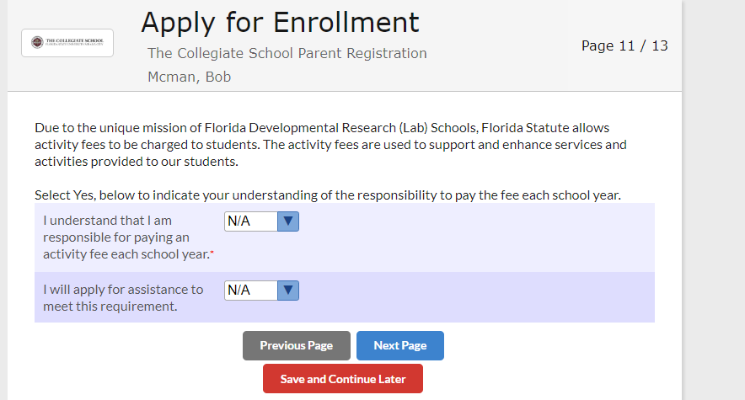

Check the box to acknowledge the TCS statement above, complete parent name and date and click “Next Page”:
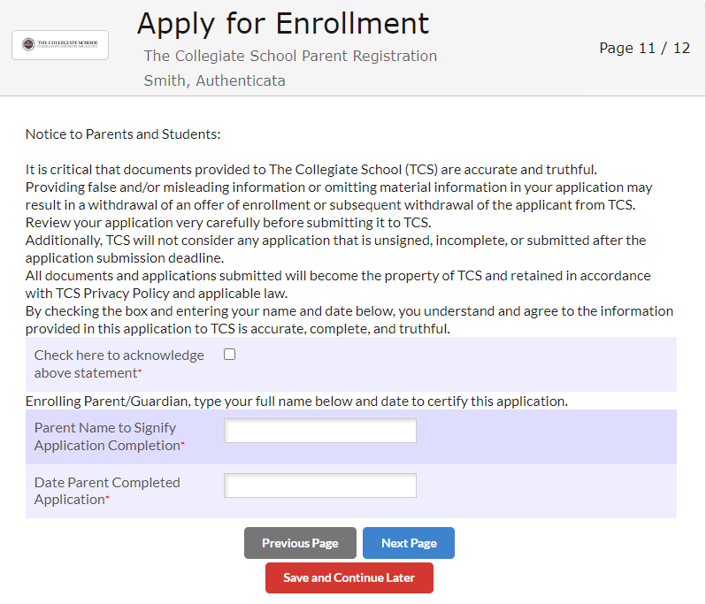

Download required records/documents info each file box, check box to acknowledge application completion and click “submit and finish box”:
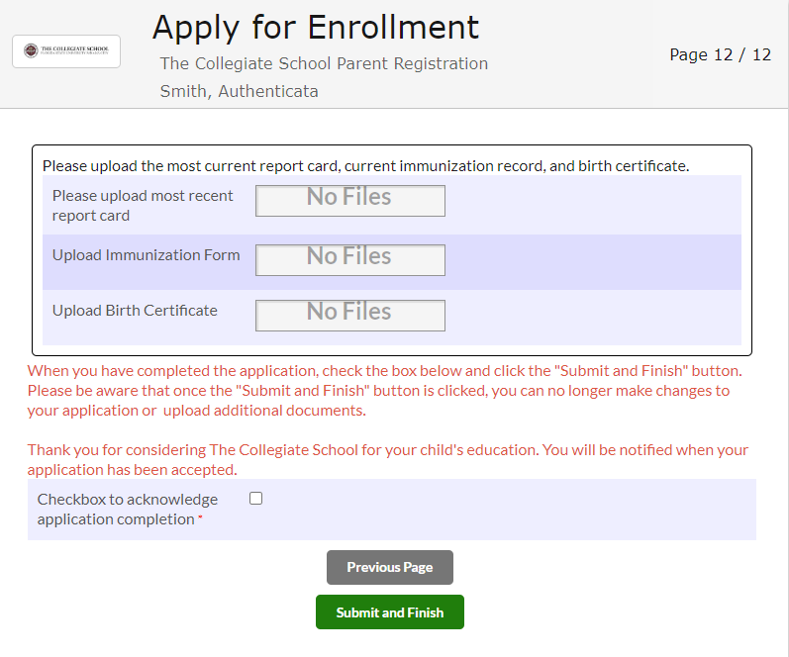
You are now complete once you see the screen below:
